|  |  |  |  |  |  |  |  |  |  |  |  |  |  |  |  |  |  |  |
| --- | --- | --- | --- | --- | --- | --- | --- | --- | --- | --- | --- | --- | --- | --- | --- | --- | --- | --- |
|  |  | Quantum Super Cars Rental  **Group 18**  Human Computer Interaction  DT228-2  Student Names: Maximilian Mihoc, Tomas Higgins, Arnaldo Fernandes, Adam Miedziejewski   |  |  | | --- | --- | |  |  | |  |  | |  |  | |  |  | |  |  | |  |  | |  |  | |  |  | |

Table of Contents

1. Introduction 3

2. Integration 6

3. Presentation 7

4. Conclusion 13

## Introduction

* 1. Executive Summary

We have decided to design a website for a car rental business. We want to target a specific untouched car rental market in Ireland. High end super cars are not common, and our website will try facilitate this need for speed. We will design our website with wealthy users in mind.

We plan to use html5 and CSS to design the layout of the webpage. We will use PHP and SQL to code the database and use MySQL to run the database. We will use a database to store all the details of each car. The details include price, engine, top speed, colour, doors and boot size.

The website will have log in and register functions, the information of each user will be held in the database. We will keep track of the user session, this means we can show the user what car he/she has rented.

We can also sort the cars by specific qualities like speed or price using the information we have stored in the database.

* 1. Goals, Purpose and Aims
* A database that can store user and car information.
* To keep the user in mind, at all stages of the project. (User Centred).
* To accomplish class assignment working in groups
* To implement Nielsen's heuristics
* To use Lifecycle User Oriented Model
* To use Mental models
* To use Metaphors
* To use CSS
* To use PHP
* To use HTML
  1. Objectives
* To enable high end spenders to rent cars not normally available in Ireland.
* To make a simple layout that's easy to use.
* To make a good looking website that would entice discretionary users.
* The system will track the time of rental duration and it will issue a receipt.
  1. Requirements

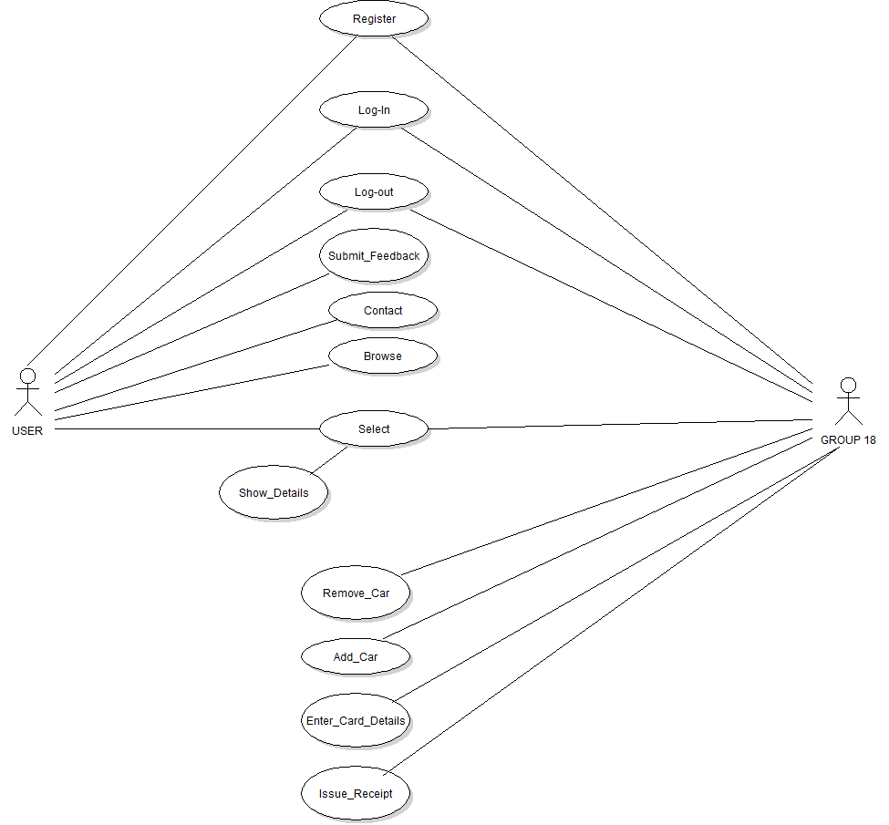

* 1. Deliverables/ Contribution

Equally split between group members.

* 1. Languages & platforms used

Languages:

**CSS -** We will use a cascading style sheet to store all the information about fonts, sizes and layout of the html page.

**SQL -** We will use structured query language to set up the database - to make the tables and populate them. We will also use SQL when performing queries against the database.

**PHP** - We will use PHP to format the data from the database and to display it on the website. We will use PHP to allow the user to log in and register. We will also use it to submit feedback forms and use credit card to pay for a car.

**JavaScript** - We plan to incorporate JavaScript into the website for animated buttons.

**HTML** - We will use HTML to design the layout of the website, links, forum layout, header and footer.

Platforms:

**Xampp -** We will use Xampp to run The MySQL Database and PHP code.

**MySQL** - We will use MySQL as our database.

**ME4 -** We will use Microsoft Expression 4 when designing our html WebPages.

**Photoshop** - For graphics processing (trimming, cropping).

**Power Point -** To produce diagrams (architectural and technical designs).

## Integration

2.1 Layout

In medium fidelity prototype we tried to capture all main functionalities, colours and layout in general. We placed side-menu on left hand side and put the right links in to it. In top right corner we put text boxes for login and password on opposite side logo and name of company. We also placed visible telephone number in case customer would like to book a car by telephone.

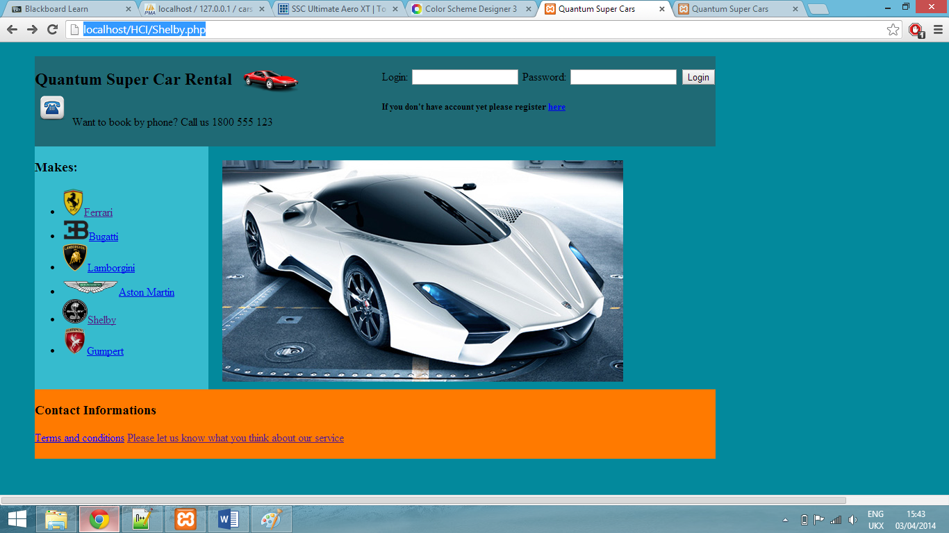

2.2 Colours, Consistency and mapping

To choose right colours we used "Colour Scheme Designer". All pages using the same layout and colour scheme to keep consistency. For correct mapping we used links. All positioning, colours and fonts are set in CSS file.

2.3 Data

All cars details and descriptions are stored in SQL database.

## Presentation

3.1 Components

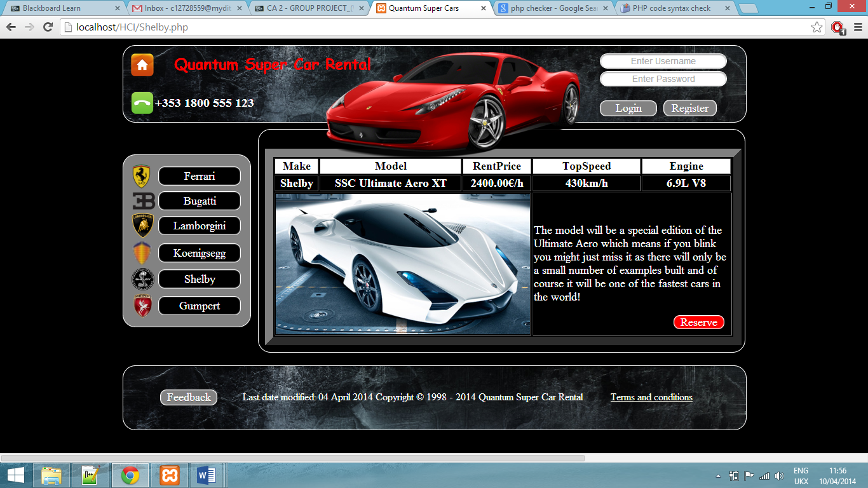**Banner –** Contains login fields, company name and telephone number:

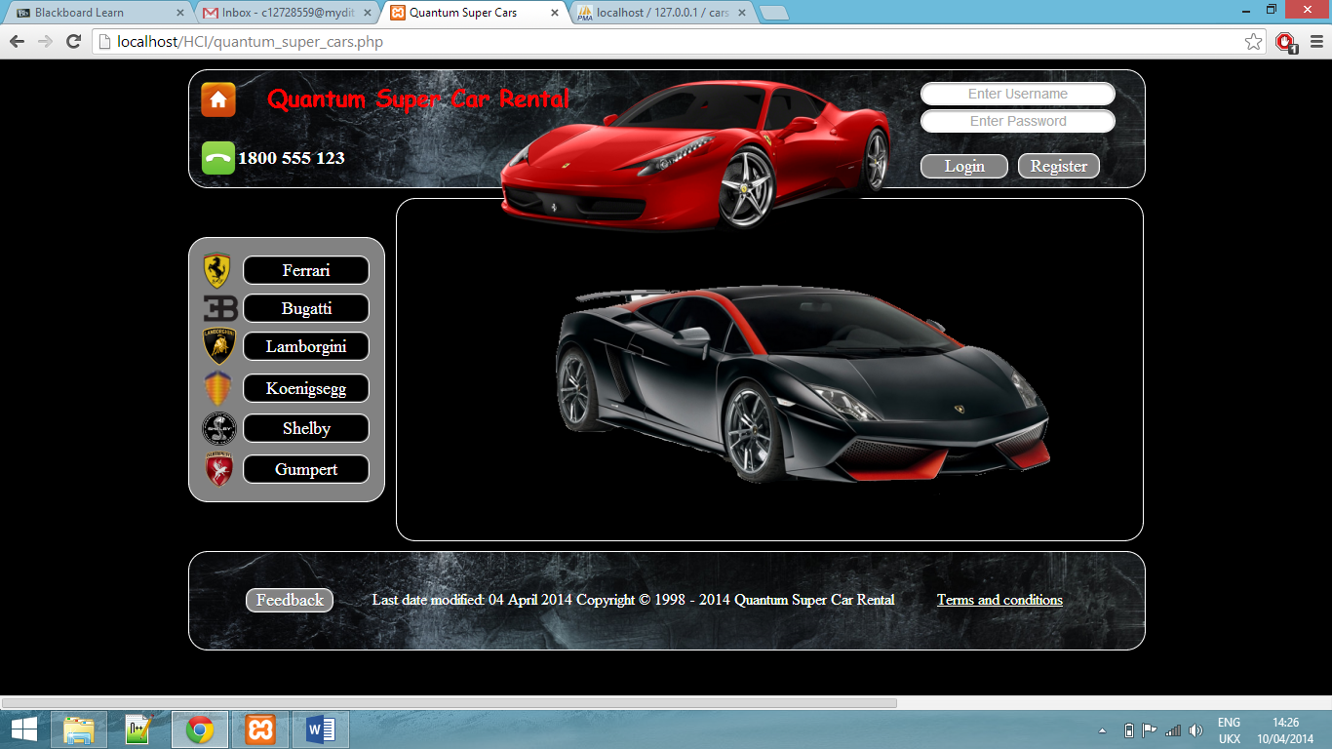**Home page**:

**Ferrari page:**

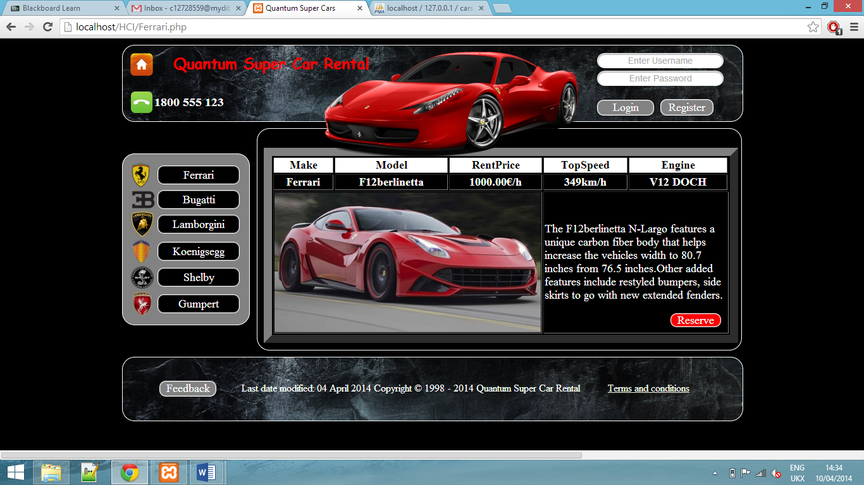

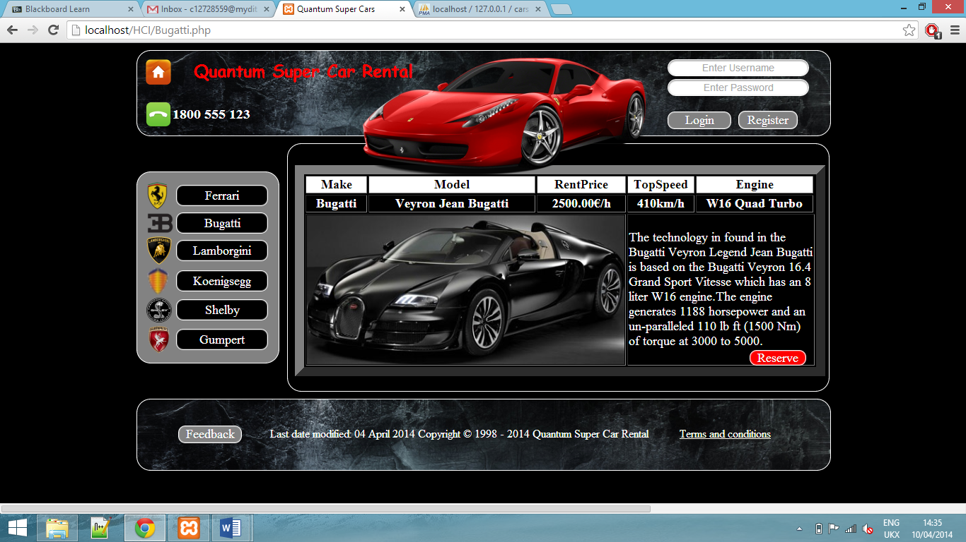**Bugatti page:**

**Lamborgini page:**

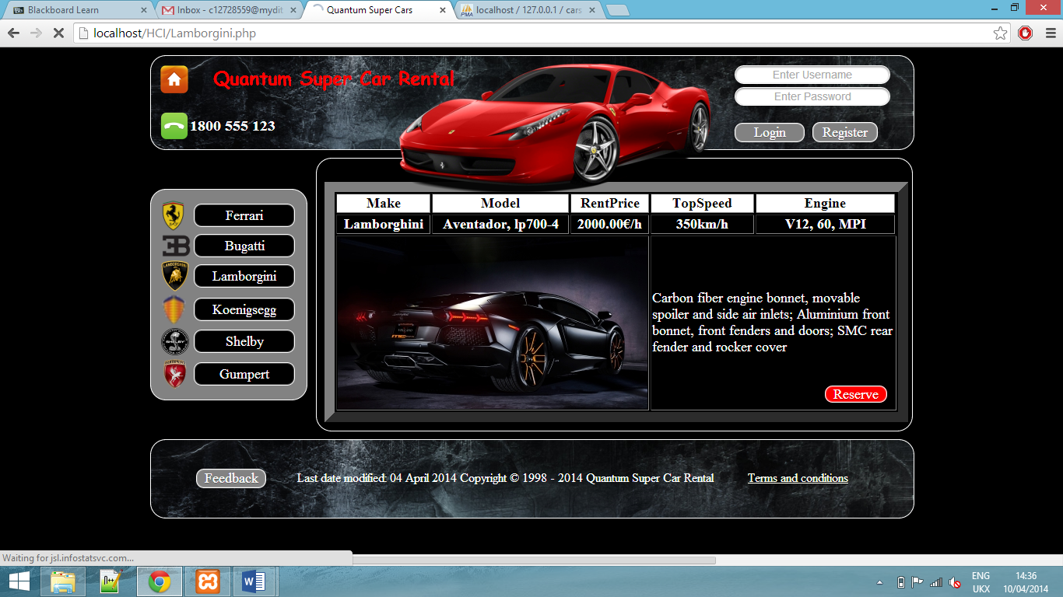

**Koenigsegg page:**

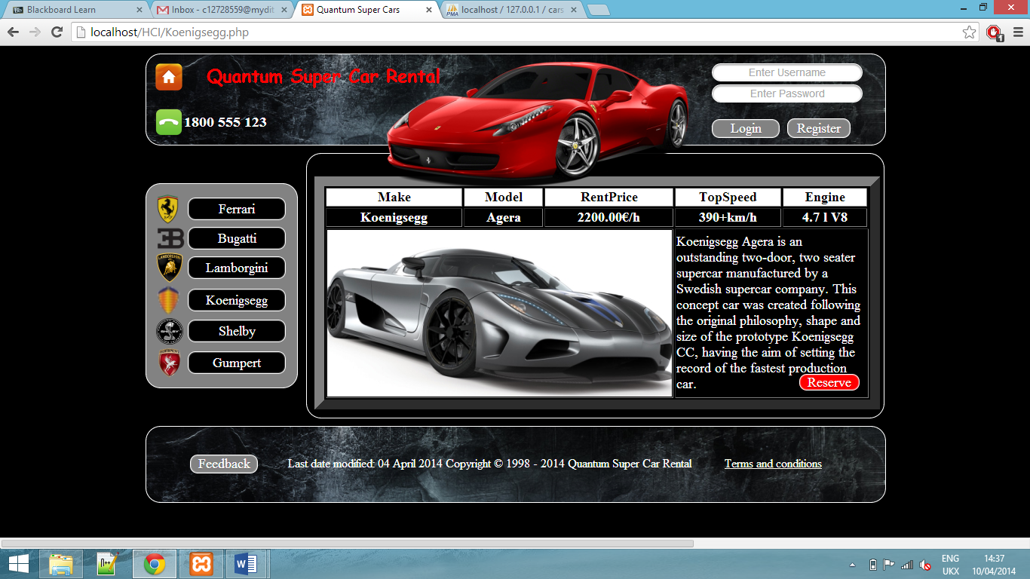

**Shelby page:**

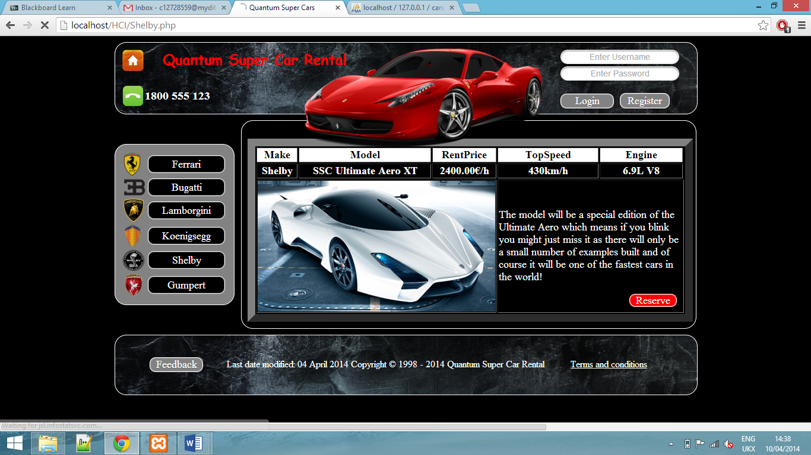

**Gumpert page:**

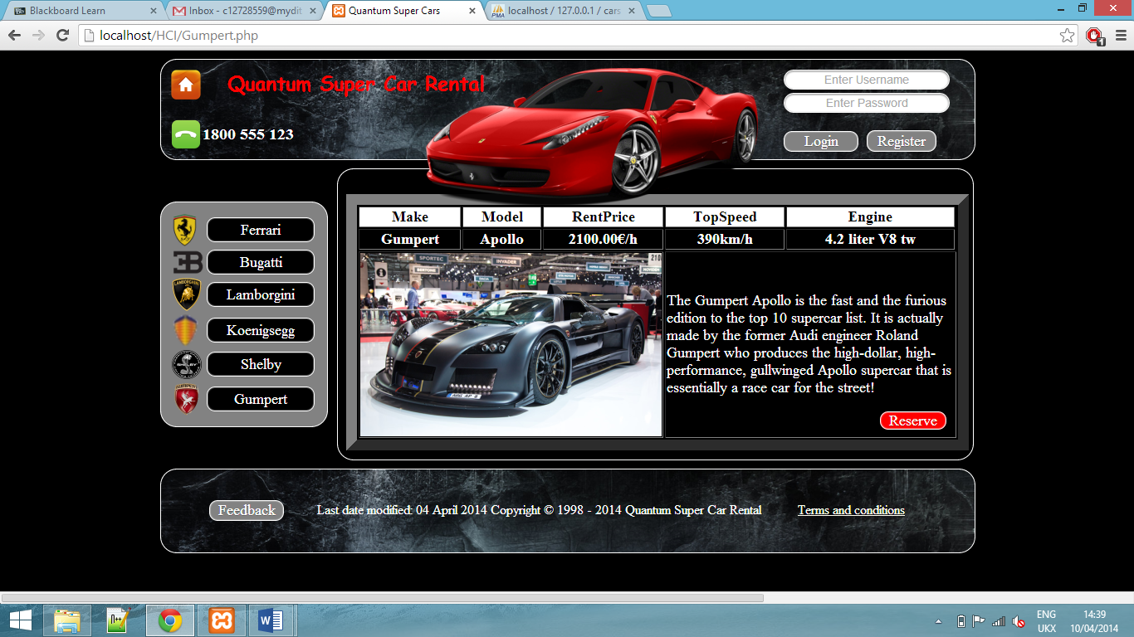

* 1. Usability

1. Visibility (navigation links) – side menu box, Terms and conditions, Login buttons, Register, -Reserve car, Home button
2. Branding (unique names for each link) – mark links clearly
3. Match between user and real world – speak user language and use right terminology

* Consistency and standards: website dimensions (600 x 980), colours (using the scheme)
* Understand ability

1. User control and freedom: Home button
2. Reset and return in register form
3. Consistency and standards

* “IEEE” – Mapping HTML to database
* Html.net and W3 schools standards

1. Help user recognize, diagnose and recover from error
2. Login form and register form
3. Lifecycle model
4. Recognition rather than recall : Phone icon, Car pictures
5. Mental model
6. Prototyping tools: pen and paper for Low fidelity prototype,
7. For Discretional Users – it has to be good, catch the user attention, make people to stay on our website
8. Nielson Heuristics
   1. Principles

Nielson Heuristics

1. Visibility -> We used unique names for car makes in main menu which are links to other pages about the specific make.
2. Match between system and real world -> language terminologies easy to understand for user.
3. User control and freedom-> We want to provide a home button on each page providing emergency exit for users and make users to be in control all the time.
4. Consistency and standards -> IEEE standards (mapping between menu and database)
5. Help users recognize, diagnose and recover from errors -> Error detection in registration form and in credit card details form.
6. Recognition rather than recall -> Use mental models so users do not have to use their brain too much. For example we will have a home icon that links to home page (Metaphor).
7. Flexibility and efficiency of use -> Allow users to tailor frequent actions.
8. Aesthetic and minimalist design
9. Help and documentation

Gestalt lows of perceptual organisation

1. Proximity: Buttons in the side bar, Login buttons on the top right, footer, phone number next to phone icon.
2. Similarity: buttons have the same shape and colour to be seen as belonging together.
3. Closure: On the header of our website we use closure. The picture of the car overlays the header layer, which completes the missing, parts of the layer, so that it appears as a whole. Closure also applies to the content layer with the same picture.
4. Symmetry: The website is symmetrical about a centred horizontal axis.

Metaphors

1. logos of the brands
2. home button
3. phone logo
4. picture of the sports car on header
   1. Tiers
5. Presentation/Client Tier – The client will be able to register, search a specific car, reserve and pay.
6. Business Logic Tier – Main functionality of this project are: Register, Log in, Search for a car, reserve the car, pay and log out. User can also leave feedback; he will be able to check car details including model, availability, price, engine and top speed.
7. Data Persistent Tier – In our project, the website will be connected to SQL database which will contain user details, car details, reservation details, payment details (in case of reservation) and feedback/reports. Main menu will be mapped with the database. It will contain the makes of cars.

## Conclusion

4.1 Revisit the objectives

* To accomplish class assignment working in groups – accomplished.
* To implement Nielsen's heuristics – accomplished.
* To use Lifecycle User Oriented Model – accomplished.
* To use mental models – accomplished.
* To use Metaphors – accomplished.
* To use CSS – accomplished.
* To use PHP – accomplished.
* To use HTML – accomplished.
* “To enable high end spenders to rent cars not normally available in Ireland.”

The website has all elements’ that would that would be needed to achieve this, apart from the cars.

* “To make a simple layout that's easy to use.”

The layout is very simple with very low link nesting. This makes it easy for the user to navigate about the website.

* “To make a good looking website that would entice discretionary users. “

We tried making the website look applying to a rich user; however we are unsure if it meets the very high professional standards for such a website.

* “A database that can store user and car information.”

Yes the database works very well; the information stored in the database is retrieved by php and SQL code and then displayed on the website.

* “To allow a user to register, login, logout and submit feedback on our website.”

The use can log in and register, however the feedback is not pushed to our server.

* “To keep the user in mind, at all stages of the project. ( User Centred).”

We tried to think what the user would like in a website as such as this, we felt a lot of pictures short but sweet information would appeal to the user.

* “The system will track the time of rental duration and it will issue a receipt” .

We failed to accomplish this, we created the database functionality for this to work, however we never got around to writhing the php. This is something we could implement in future work.

4.2 Challenges

We wanted to have all the data on the website stored in the database. We tried to save the pictures in the database; however we faced some issues with this. We decided to place the pictures inside the website html instead.

One Challenge we faced, was that when a user had logged into the site it should no longer show the log in and register buttons. This was a issue because we had the code for log in in html. We overcame this challenge, by using “echo “ to convert the html to PHP . Then we used a if statement, that used session tacking to see if a user was logged in. If this was the case “Hallo username “was printed on the screen.

4.3 Future work

We gain a lot of understanding of how a website and database can be linked, in the process of making this prototype. From this we can see how this technology can be used for later projects. We also found that the members in the group worked well in a team, so it’s possible we would like to work together again.

However I feel that the project topic could be more interesting than cars, so if we were going to do it again, we might do something different.

4.4 References

* Research into the best supercars in the world:

<http://www.top10supercars.com/ssc-ultimate-aero-xt/>

* A website that rents luxury cars across Europe:

<http://europe.hireluxurycar.com/ireland/rent-supercars>

* Websites for coding standards:

<http://html.net>

<http://www.w3schools.com/>

<http://phptester.net/>